Project Title: Bankruptcy Risk Prediction Using Financial RatiosTable
CSBU 5420 | Machine Learning
By
Satwika Nadimpally
2026

Executive Summary
The present project is aimed at forecasting corporate bankruptcy with the help of machine learning algorithms with respect to financial ratios data. Investors, financial institutions, and regulatory authorities should identify financially troubled companies early to reduce the risk and make the right decision. The data set used in the study is a bankruptcy one that has the financial indicators which define the financial health of companies.
In Altair AI Studio, the dataset was preprocessed with the help of managing missing values, normalizing numerical features, and transforming the target variable into a binomial classification label. The Exploratory Data Analysis (EDA) was performed to learn more about the distribution of main financial ratios and identify possible outliers.
Three classification models Logistic Regression, Support Vector machine (SVM) and Random Forest were also applied. A train-test split of 80/20 was used to train the models and metric performance measures like accuracy, precision, recall, F1-score and AUC were used to evaluate the results.
The best overall performance was recorded in the Random Forest classifier with an accuracy of about 96.7 percent and an AUC of 0.906 which means that it is effective at separating between bankrupt and non-bankrupt companies. The findings indicate that machine learning models can be useful in the process of financial risk assessment and bankruptcy prediction but certain difficulties arise because of the balance of the dataset.

Introduction
Describe the issue of prediction of corporate bankruptcy and the significance of the detection of financial risks to investors and organizations.

Data Description - Dataset Overview
The dataset used in this study is the Company Bankruptcy Prediction Dataset obtained from Kaggle. The data set of the financial ratios and indicators will be used to determine whether a business will go bankrupt soon. The sample has 5,455 observations and 95 financial measures, which are different profitability, liquidity, and leverage ratios. The target variable Bankrupt? represents the presence of bankruptcy of a company (1), or the financial stability (0). The data were imported into RapidMiner to undergo preprocessing and exploratory analysis and creation of machine learning models.
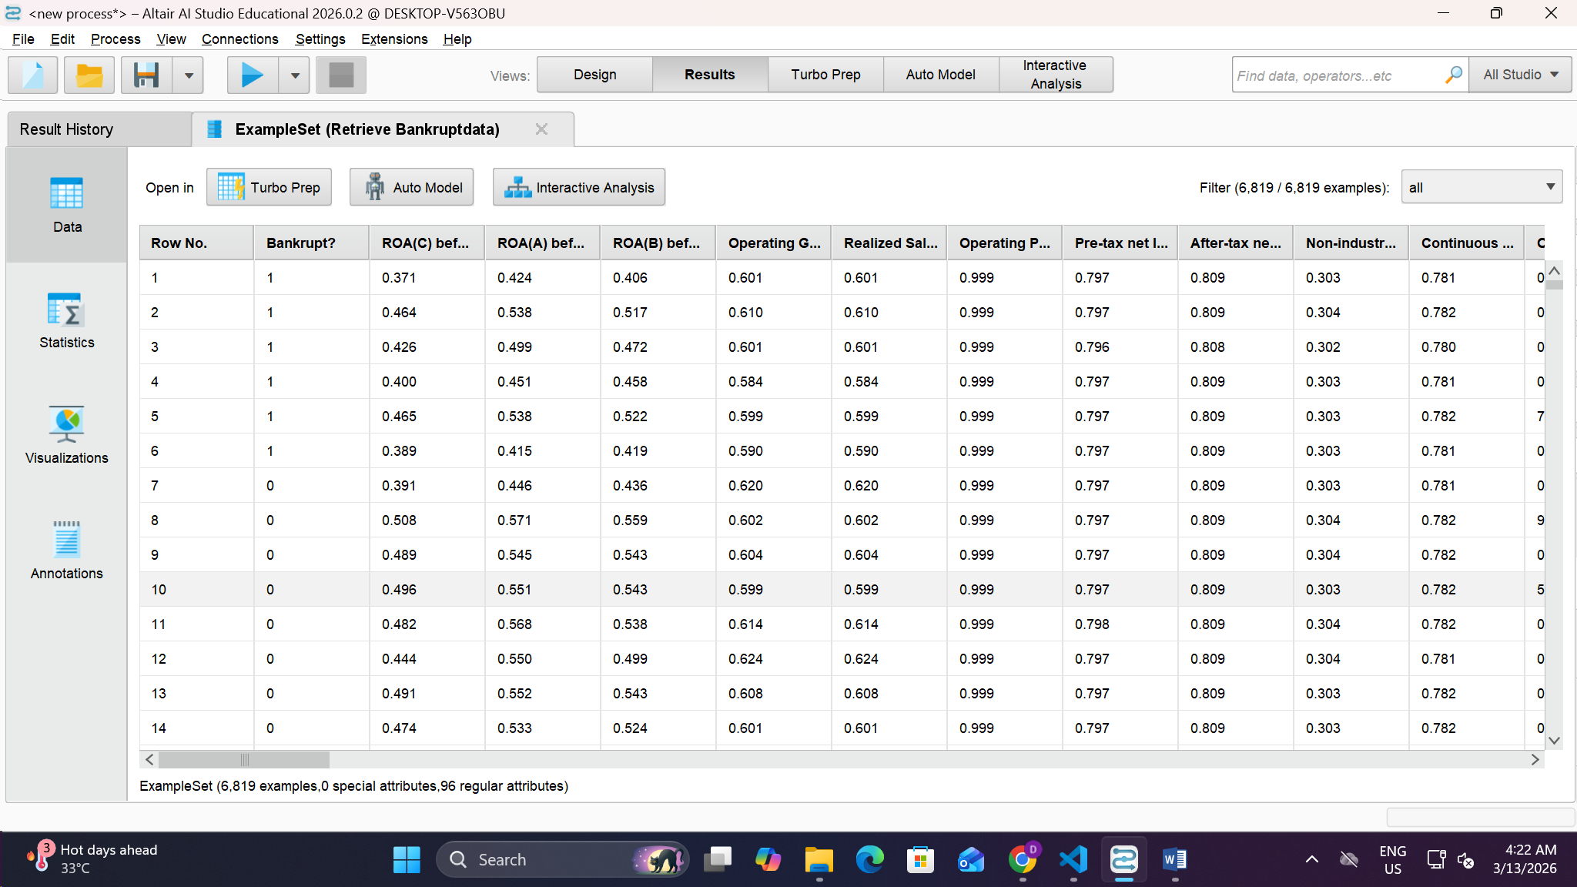Fig1: Dataset

Data Preprocessing

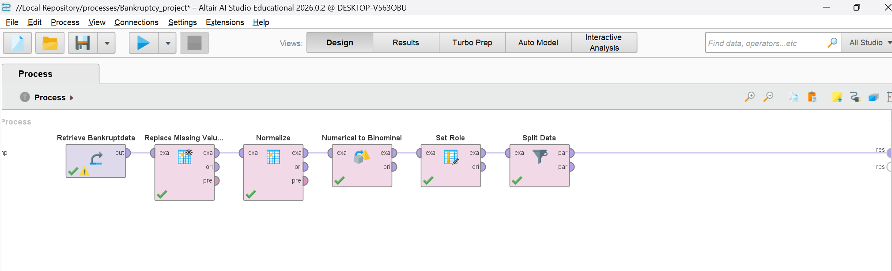Fig2: Retrieve → Replace Missing Values → Normalize → Numerical to Binominal → Set Role → Split Data
The preprocessing of data was perform to develop machine learning models. Firstly, the data were loaded into RapidMiner with the help of the Retrieve operator. The Replace Missing Values operator was used to solve the missing values in the data to guarantee the completeness of data and improve data quality. This was followed by feature scaling by using the operator normalize that employs Z-transformation to normalize the financial ratios so that all the attributes are at a similar scale.
Numerical to Binomial operator was then used to transform the target variable Bankrupt? to a binomial variable, which makes it possible to address the problem as a binary classification task. Bankrupt? was defined as the label (target variable) by using the Set Role operator (Géron, 2019). Lastly, the dataset was split into training and testing sets using the Split Data operator with a ratio of 80/20 which allowed the models to be trained on a subset of the data and tested on the unseen data to determine the predictive performance.
Step | Operator Used | Description
1 | Retrieve | The bankruptcy dataset was imported into Altair AI Studio from the repository for analysis.
2 | Replace Missing Values | Missing values in the dataset were handled to ensure data completeness and prevent errors during model training.
3 | Normalize (Z-Transformation) | Financial ratio attributes were standardized so that all features are on a comparable scale and no variable dominates the model due to larger magnitude.
4 | Numerical to Binominal | The target variable Bankrupt? was converted from numerical format into a binominal categorical variable to represent two classes: bankrupt and non-bankrupt.
5 | Set Role | The Bankrupt? attribute was assigned as the label (target variable) so that machine learning algorithms can learn to predict bankruptcy status.

Exploratory Data Analysis - Univariate Analysis
Bankruptcy Distribution
The results of the analysis of the target variable Bankrupt? were represented in a bar chart. The visualization indicates that the data is very skewed with non-bankrupt firms as compared to bankrupt companies. This imbalance must be taken into account during the assessment of machine learning models so that the prediction performance of those models is accurate (Bishop, 2006).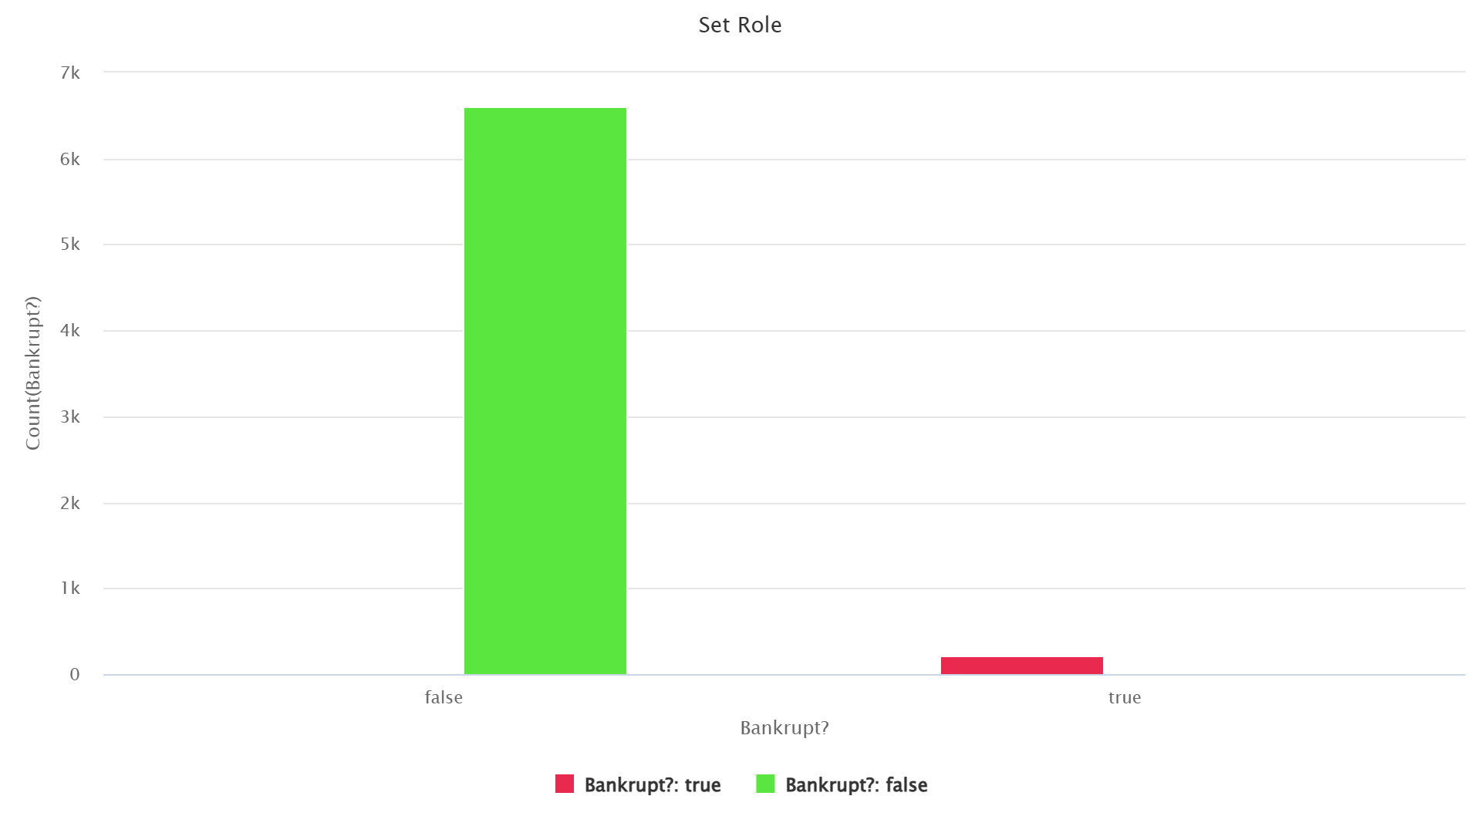 Fig3: Distribution of Non-Bankrupt vs Bankrupt Companies
Profitability Distribution
A histogram was generated to examine the distribution of the financial ratio “ROA(C) before interest and depreciation before interest”. . The distribution shows that the majority of the companies are concentrated around the moderate values of profitability, which are around zero. Nonetheless, other firms are showing negative profitability ratios, which indicate that they may experience financial distress. Fewer companies show increased levels of profitability. The existence of the negative and positive values demonstrates that the performance of companies in financial terms is varied.
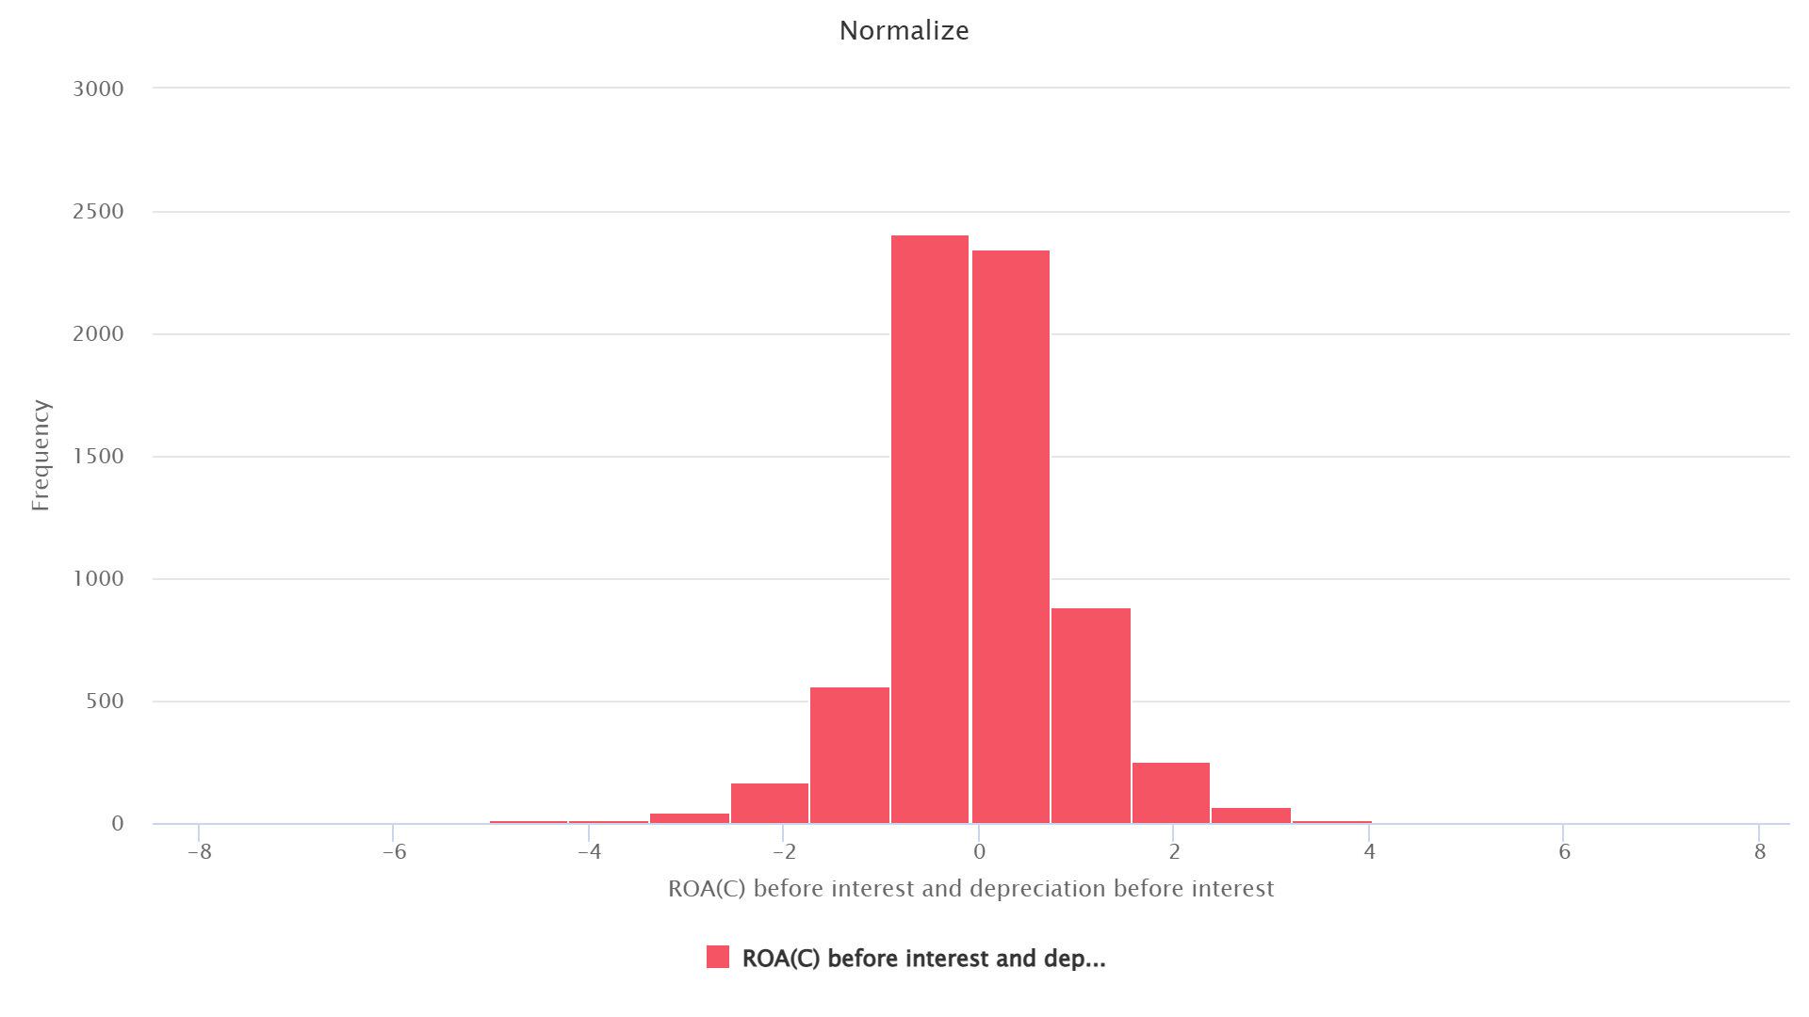Fig4: Distribution of ROA(C) Before Interest and Depreciation

Exploratory Data Analysis - Bivariate Analysis
The analysis of the relationship between profitability and the bankruptcy status was performed in a boxplot. The comparison of the financial ratio ROA(C) before interest and depreciation was made between the bankrupt and non-bankrupt companies. The visualization demonstrates that the values of profitability of bankrupt companies are lower than they are in financially sound companies. This implies that a decrease in profitability rates can be viewed as a high pointer towards the threat of bankruptcy.
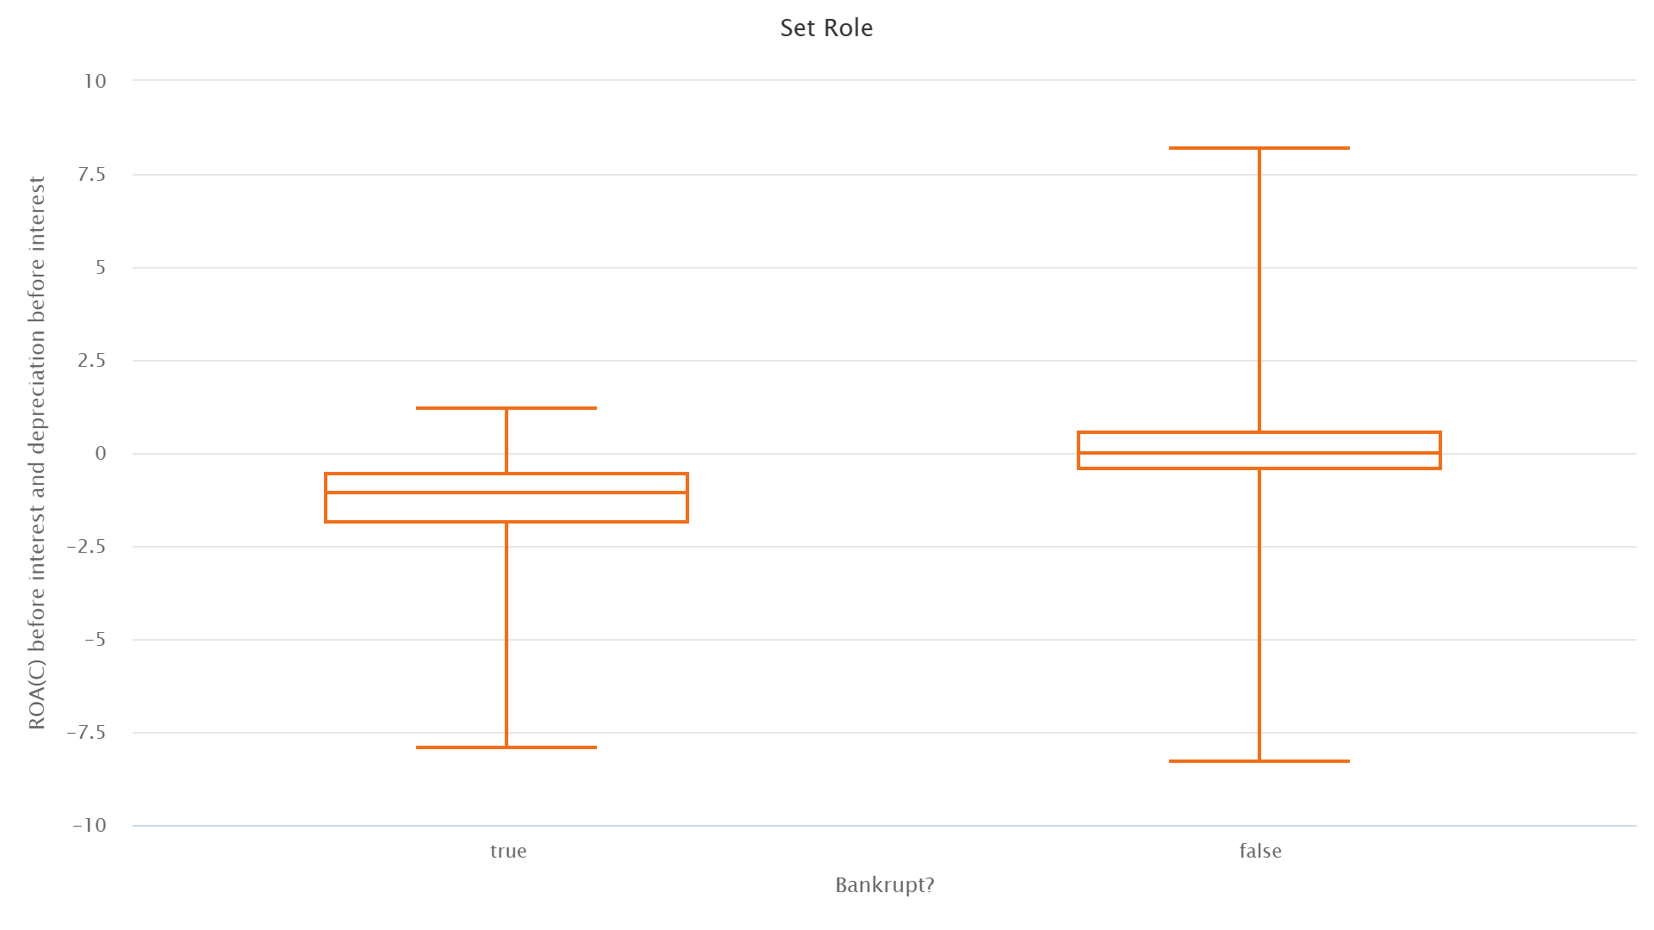Fig5: Profitability Distribution by Bankruptcy Status

Outlier Detection
The boxplot was used to identify outliers in Operating Gross Margin variable as bankrupt and non-bankrupt companies were compared. The visualization indicates that there are a number of extreme values especially in non-bankrupt firms and this shows a diverse range in the operating performance. Bankrupt firms have low operating margins and a reduced variability. Such extreme observations show a great variation in financial performance by companies.
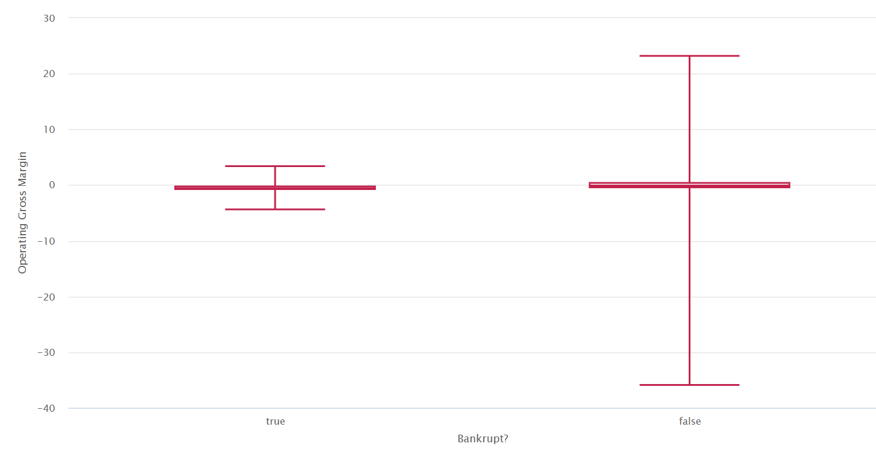Fig6: Outlier Detection in Operating Gross Margin by Bankruptcy Status
Below boxplot was applied to find out possible outliers of the financial ratio ROA(A) before interest and after tax. The display of the visualization indicates that the majority of the companies have the values of profitability concentration around the zero point, and a number of observations are much higher and lower than the interquartile range. These extreme values identify firms with abnormally high or low levels of profitability and point to the variability in the financial performance of firms.
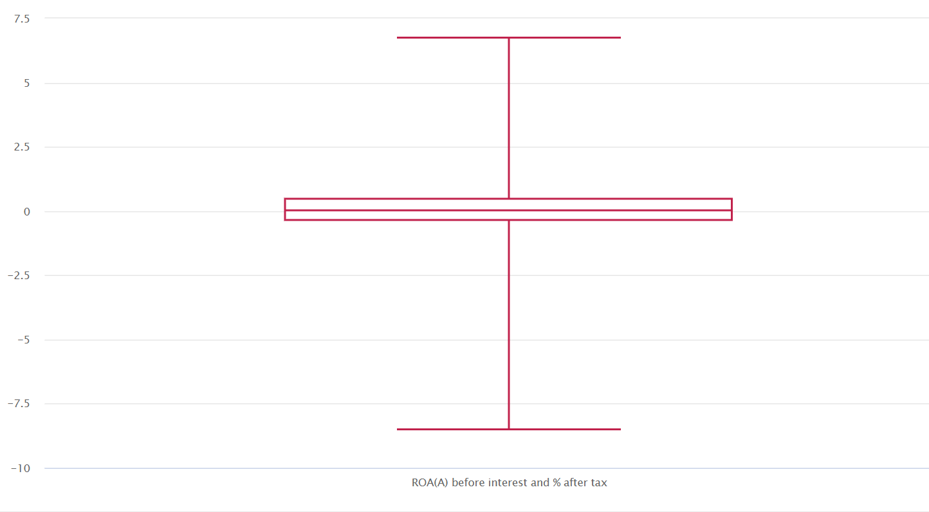Fig7: Outlier Detection in ROA(A) Before Interest and After Tax

Modeling - Logistic Regression

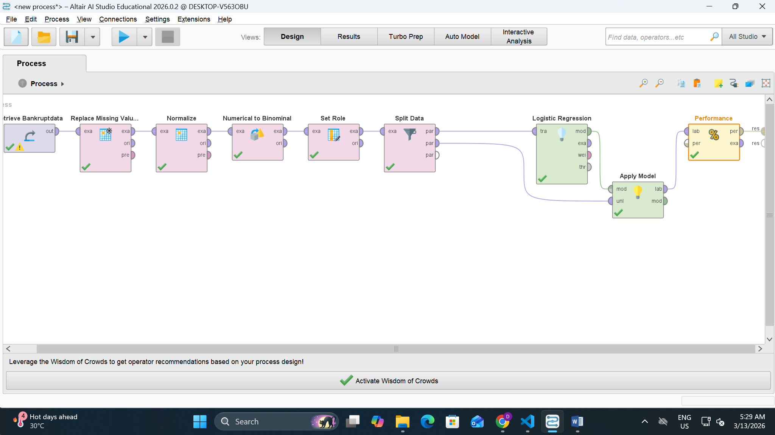
Fig 8
A Logistic Regression classification model was created with Altair AI Studio (RapidMiner) to forecast the corporate bankruptcy. The first step was to retrieve and preprocess the data set to guarantee quality of the data. The Replace Missing Values operator was used to deal with missing values and a standardization of the financial ratios was done with Z-transformation normalization.
The Numerical to Binomial operator was used to transform the target variable Bankrupt? to binomial form and the Set Role operator was used to assign the target variable the label. The Split Data operator with a 80/20 value was then used to partition the dataset into training and testing ones.
The training data was used to create a Logistic Regression model which was then used on the testing data through the Apply Model operator. Lastly, the model performance was measured with the help of the Performance (Binomial Classification) operator that resulted in the creation of accuracy, precision, recall, F1 score and AUC metrics. The model uses this workflow to learn a pattern based on the financial ratios and assures its success in predicting the probability of a business going bankrupt.

Confusion Matrix Analysis
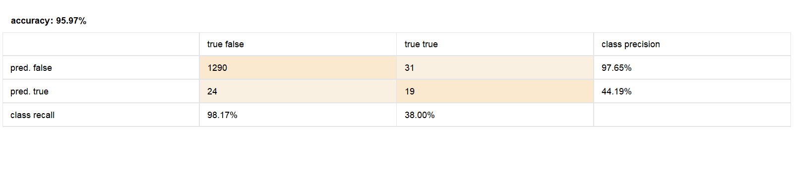
Fig 9
The confusion matrix is a summary of the classification findings of the Logistic Regression model. It contrasts the projected labels and the real bankruptcy of companies, which is the actual state of companies.
 | Actual Non-Bankrupt | Actual Bankrupt
Predicted Non-Bankrupt | 1290 | 31
Predicted Bankrupt | 24 | 19

Performance Metrics
The Logistic Regression model achieved the following performance metrics:
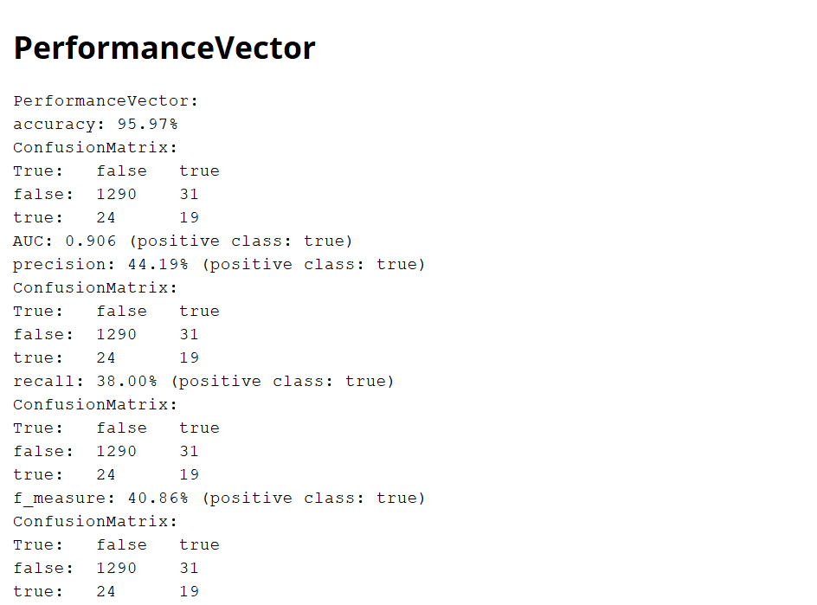
Fig 10

AUC (Area Under the ROC Curve)
The model attained an AUC of 0.906 and this is a good sign of high classification. The Area Under the Receiver Operating Characteristic (ROC) Curve is a measure of the rate at which the model is able to discriminate between bankrupt companies and non-bankrupt companies.
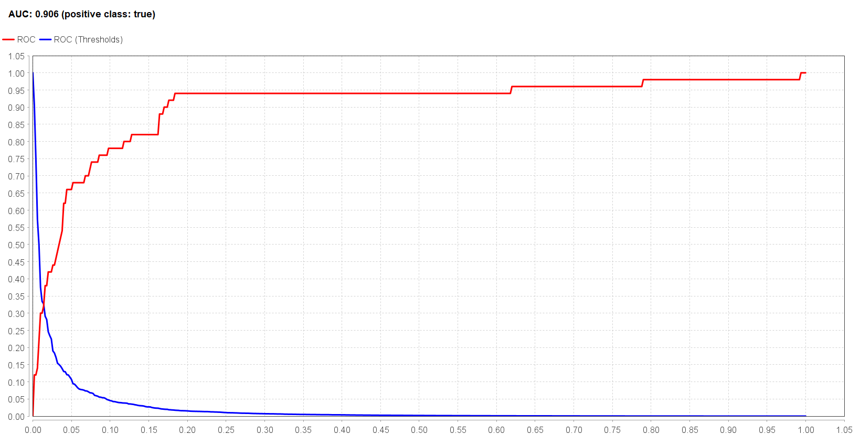
Fig 11

Modeling - Support Vector Machine
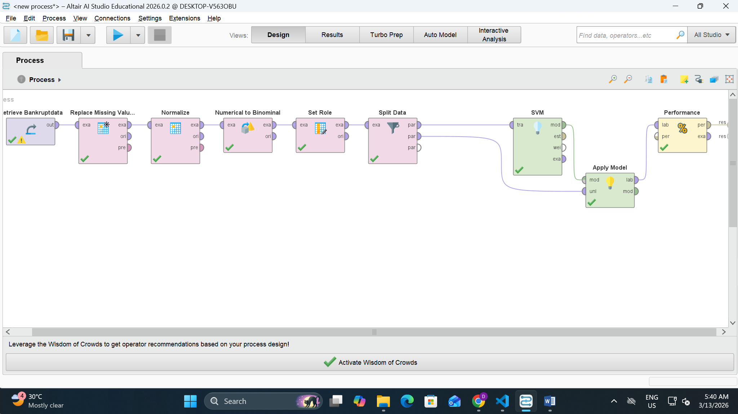
Fig 12
To assessing the performance of a bankruptcy prediction, a Support Vector machine (SVM) classification model was adopted with the help of Altair AI Studio (RapidMiner). The preprocessing steps that were implemented in the previous model were consistent. The dataset was initially fetched and purged by the Replace Missing Values operator and the financial ratio characteristics were found by the Z-transformation normalization.
The target variable Bankrupt? which was transformed into a binomial categorical variable with the Numerical to Binomial operator and the label was set with the Set Role operator. The data was then divided into training and testing sets with the Split Data operator with the ratio of 80/20.
Confusion Matrix
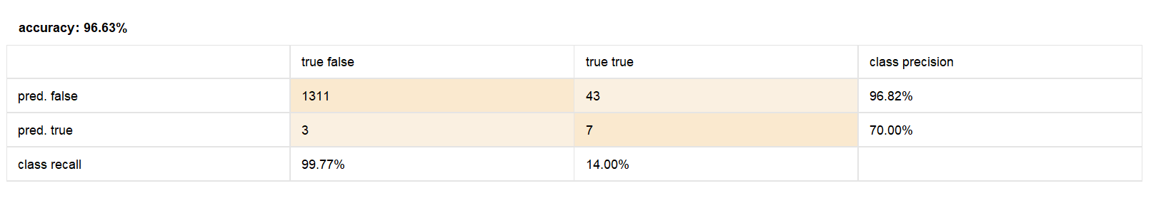
Fig 13
The confusion matrix indicates the ability of the SVM model to classify. The model properly categorized 1311 non-bankrupt firms and 7 bankrupt firms. Nevertheless, 43 insolvency companies were not reported as bankrupt, and 3 insolvency companies were not forecasted as non-bankrupt. This shows that the model does a good job in the identification of non-bankrupt firms and little can be done in the identification of the cases of bankruptcy.
Predicted / Actual | Non-Bankrupt (False) | Bankrupt (True)
Predicted Non-Bankrupt (False) | 1311 | 43
Predicted Bankrupt (True) | 3 | 7

Performance Metrics
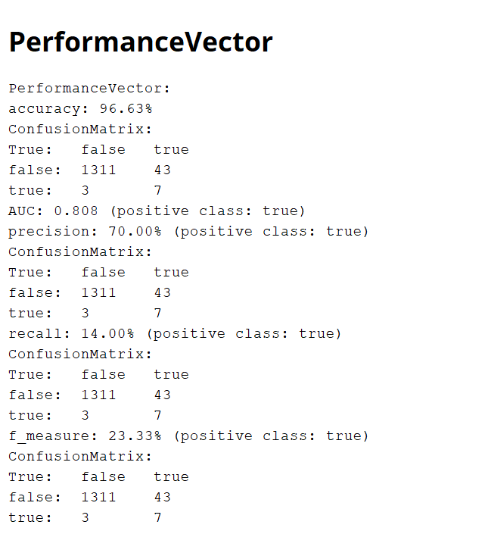
Fig 14
The SVM model had the accuracy of 96.63% which shows that there was a good overall classification performance. The accuracy of the bankrupt category is 70 which implies that when the model predicts that it is bankrupt, it is accurate in most cases. But, the bankrupt companies recall is 14 which indicates that the model continues to omit numerous actual cases of bankruptcy because of the disproportionate dataset.

AUC:
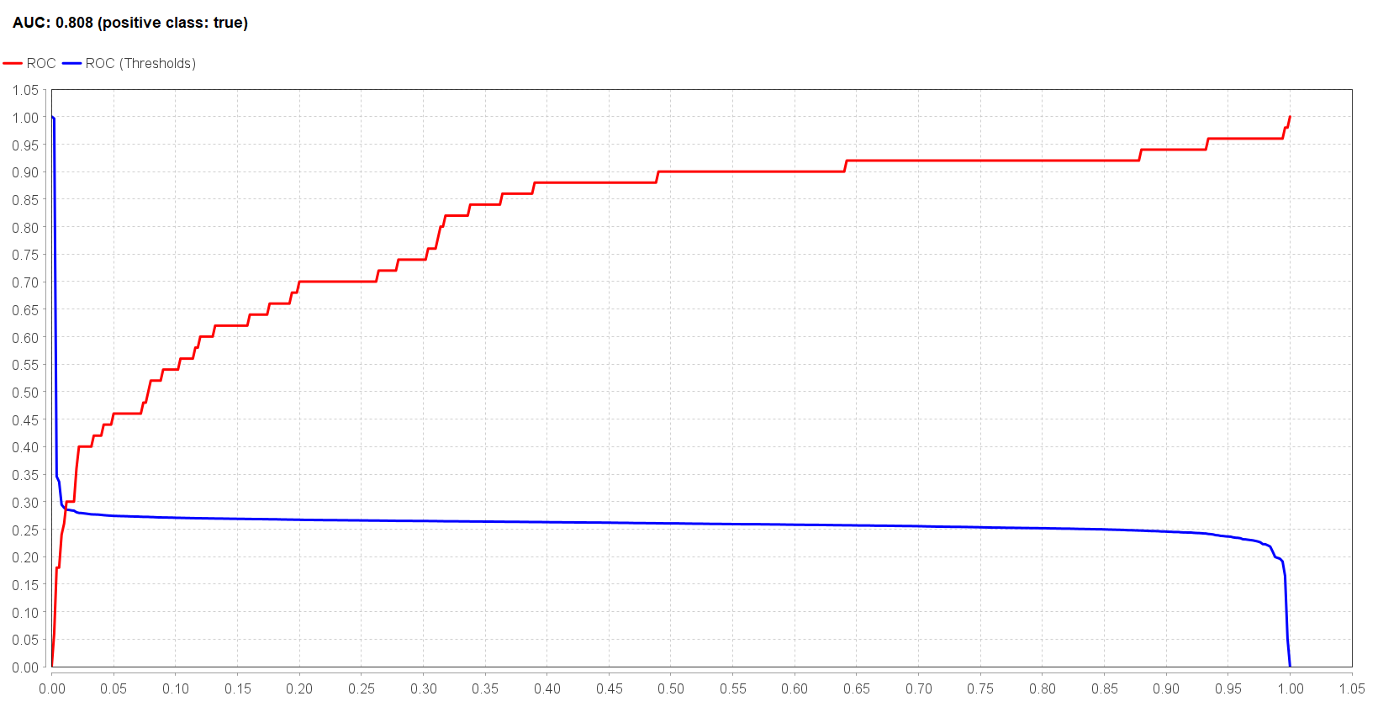
Fig 15

Modeling - Random Forest
A classification model was the Random Forest model used in the Altair AI studio to predict the bankruptcy of a corporation. The process starts with retrieving the bankruptcy data on the repository. The gaps in the data are processed with the Replace Missing Values operator to assure the quality of data. Due to the varying scales of financial ratios the Z-transformation normalization is used to ensure that none of the features have a larger contribution to the model.
The Bankrupt? attribute is then changed to a binomial variable with the help of the Numerical to Binomial operator. This attribute is then assigned this attribute as the label (target variable) through the Set Role operator to be used in classification. The Split Data operator splits the dataset into the training and test sets in the ratio of 80/20. Random Forest algorithm is trained on the training data and the trained model is applied to the testing data with the help of the Apply Model operator. Lastly, the Performance (Binomial Classification) operator measures the model against a number of performance metrics.
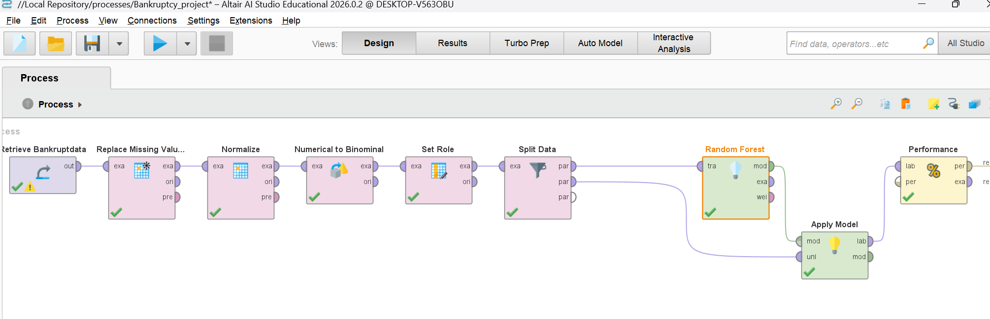
Fig 16
Performance Vector
The Performance Vector is a summary of the measures of evaluation on which the Random Forest model is evaluated. The model has reached an accuracy of 96.70 in this research implying that most of the predictions were made accurate. The model achieved a 85.71% accuracy among the bankrupt category when the model predicts that the company is bankrupt, then it is right at the majority of the times (Han, et al. 2012). This is because the bankrupt model correctly identifies the small percentage, 12, of the actual bankrupt companies in the form of the recall of the bankrupt class. The F1-score of 21.05 percent represents the tradeoff between precision and the recall of the class of bankruptcy. These measures allow giving a full assessment of the predictive ability of the model.
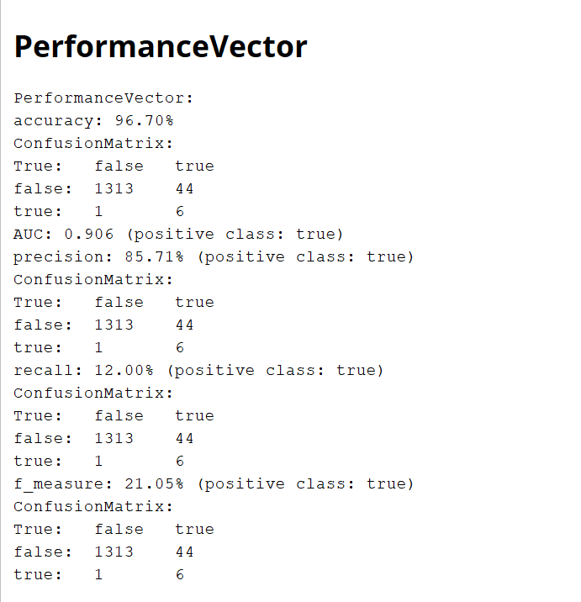
Fig 17

Confusion Matrix

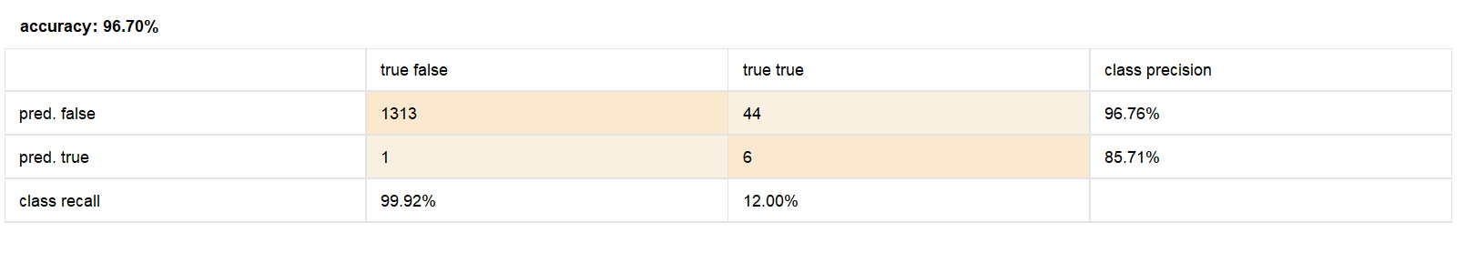
Fig 18
The confusion matrix gives a break-up of the results of the classification. The Random Forest model was able to accurately classify 1313 non-bankrupt and 6 bankrupt companies. Nevertheless, 44 bankrupt companies were falsely estimated as non-bankrupt companies whereas 1 non-bankrupt company was falsely identified as a bankrupt company. This does not mean that the model is highly successful in recognising non-bankrupt firms, but it finds it challenging to recognise bankrupt companies. This weakness arises due to the fact that the dataset is very skewed, that is, the number of non-bankrupt firms is much more than that of the bankrupt firms.
Predicted / Actual | Non-Bankrupt (False) | Bankrupt (True)
Predicted Non-Bankrupt (False) | 1313 | 44
Predicted Bankrupt (True) | 1 | 6

Area Under the Curve (AUC)
The Area under the Receiver Operating Characteristic Curve (AUC) is used to assess the capability of the model to separate between bankrupt and non-bankrupt firms at various classification levels. Random Forest model recorded an AUC of 0.906, which is considered to be a good discriminatory model. The value of AUC near the value 1.0 indicates that the model is very effective in distinguishing the two classes. The ROC curve also shows that the model has a high true positive and the false positive is relatively low.
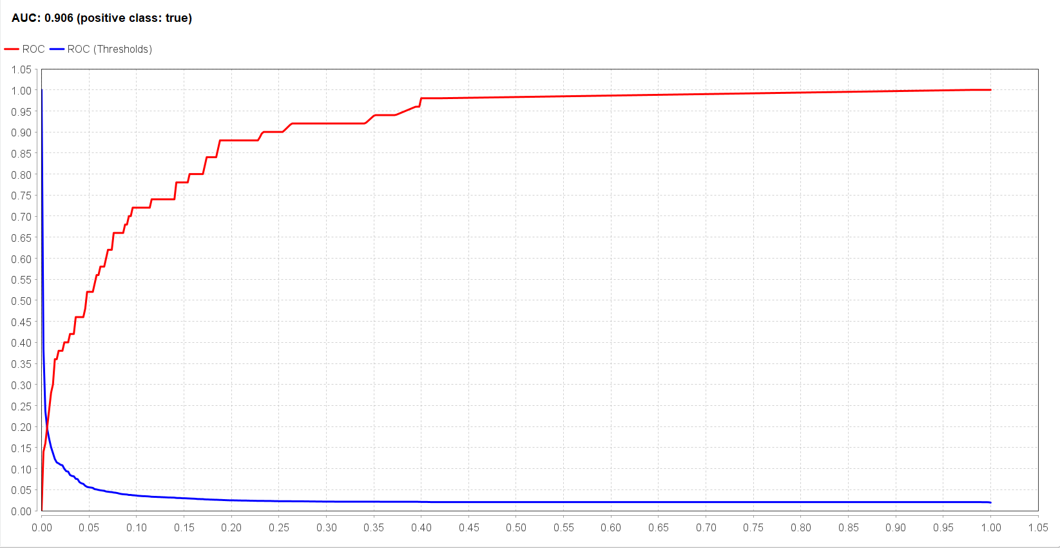
Fig 19

Final Model and Insights
Model | Accuracy | Precision (Bankrupt) | Recall (Bankrupt) | AUC
Logistic Regression | 95.97% | 44.19% | 38% | 0.906
Support Vector Machine (SVM) | 96.63% | 70% | 14% | 0.808
Random Forest | 96.70% | 85.71% | 12% | 0.906

According to the experimental outcome acquired on the basis of Logistic Regression, Support Vector machine (SVM), and random Forest models, the performance of each model was evaluated on the basis of accuracy, precision, recall, and AUC. The Random Forests classifier was the best among the compared models as it showed the highest overall performance especially in its capacity to identify the bankrupt companies and non-bankrupt companies.
The accuracy of the Random Forest model was high (96.7 percent) and the AUC was 0.906 indicating that the model had a good classification power. Despite the fact that the number of recalls of bankrupt companies was still rather low, thanks to the skewed nature of the dataset, the model was more predictive than the other algorithms.
These findings suggest that machine learning models have potential to aid financial analysts and organisations by early identifying risk of bankruptcy with the help of financial ratio data. The predictive systems can assist in making improved decisions, risks and financial planning.

References
Han, J., Kamber, M., & Pei, J. (2012). Data Mining: Concepts and Techniques. Morgan Kaufmann.
Géron, A. (2019). Hands-On Machine Learning with Scikit-Learn, Keras, and TensorFlow. O’Reilly Media.
Altair AI Studio Documentation. (2026). Altair Engineering Inc.
https://www.kaggle.com/datasets/fedesoriano/company-bankruptcy-prediction
Bishop, C. M. (2006). Pattern Recognition and Machine Learning. Springer.

